

Aeromodelling Club IIT Kanpur

# **Project:- Fusion 360**

Project Mentors:-

* **Mohit Anand**
* **Raj Agarwal**
* **Pranshu Singhal**

# **Introduction to Aeromodelling**

**Tasks to be performed under Aeromodelling**

1. **Understanding:- Basic understanding of the various components and theory involved in an aircraft to manufacture and fly.**
2. **Design:- We need some softwares to design our RC aircraft. So, we will be using Fusion 360 to create our own RC aircraft 3D model and its parts and applying appearances for styling and analysing the loads on different parts.**
3. **Build:- According to the model, we have a virtual design in our Fusion 360 which will be used to create a real RC aircraft from different materials.**
4. **Fly:- At last, we will reach our ultimate destination in which we would be flying our own RC plane designed on Fusion 360 and built on our own.**

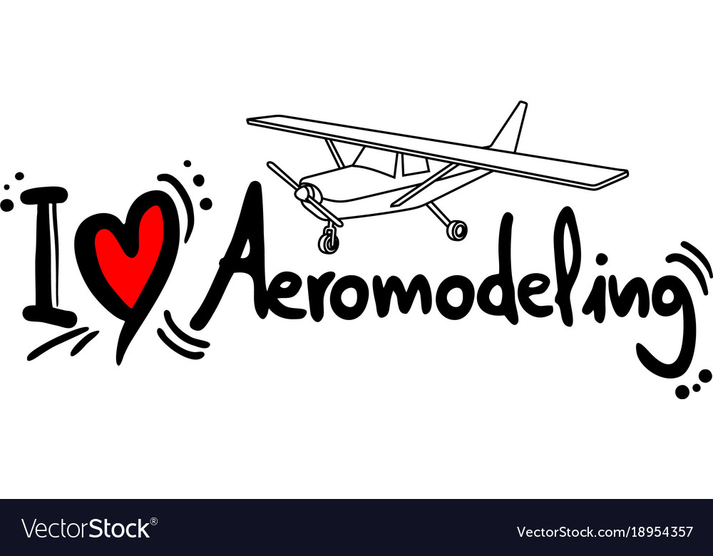

## **Basic Terminologies and Theory in Aeromodelling**

**1. Control Surfaces: - The term used to describe the moving part of any flying surface e.g. rudder, elevator, ailerons and flaps.**

**2. Wingspan: -The overall length of the wing, from left tip to right tip of the wing. This is the primary measurement when referring to a plane’s size.**

**3. Angle of Attack:-The angle at which air hits the wing, usually denoted by alpha (α).**

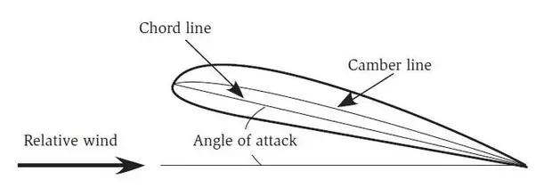

**4. Aspect Ratio: - Ratio of wingspan(b) squared to wing area(S) i.e. b2/S.**

**5. Airfoil : - The cross-section shape of a wing. Aerofoils can be flat-bottomed, semi-symmetrical or symmetrical, depending on the style of aeroplane and what it needs to do.**

**6. Leading and trailing edge: - The front edge of the wing, tailplane or rudder is leading edge while back edge of the wing is trailing edge.**

**7. Chord: - The width of the wing from leading edge to trailing edge.**

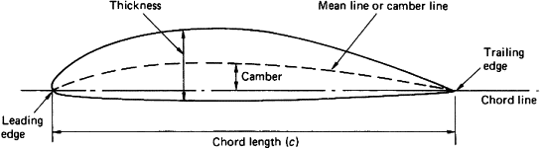

**8. Dihedral: - The angle made by wings from horizontal when viewed from the front.**

**9. Pitch: - The rotational movement of an airplane about an axis passing parallel to the wing, controlled by elevators.**

**10. Roll: - The rotational movement of an airplane about its longitudinal axis, controlled by ailerons.**

**11. Yaw: - The rotational movement of an aircraft about its vertical axis, controlled by the rudder.**

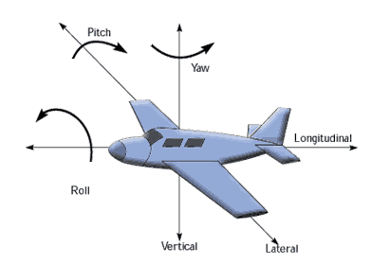

**12. Ailerons: - Moving section of trailing edge of wing . They work in opposite directions to one another in pairs, i.e. if one goes up, the other flap goes down .It controls the rolling motion.**

**13. Elevator: - Moving section of the tail similar to ailerons. It controls the pitch of the airplane.**

**14. Rudder: - The moving section on the back half of the fin. Used to control yaw.**

**15. Elevons: - Elevators and aileron made by the same control surface are elevons.**

**16. Fuselage: -The main body of an aeroplane, excluding wing, tail etc.**

**17. Flaps: - Moving sections of the trailing edge of the wing, usually found between the ailerons and fuselage.**

**18. Forces acting on an aircraft:-**

* + 1. **Drag- This force is our major enemy in aerodynamics which reduces the performance of aircraft . This is the opposing force which acts opposite to the direction of motion which reduces the velocity of aircraft. This force is applied due to pressure difference and also because of air (air friction due to viscosity of air). Sometimes this force can also be useful.**
    2. **Thrust- This is the force which helps our aircraft to move forward. This force is created by the jet engines or in our case electric motors . This force depends on the type of engine or motor we are using .**
    3. **Weight-This is the most common force on earth which we all face and also our aircraft faces. This is also called gravitational force.**
    4. **Lift- This is the force which makes the aircraft float or fly in the sky .This forces acts due to the different velocities above and below the airfoils which creates pressure difference and helps in countering the weight**

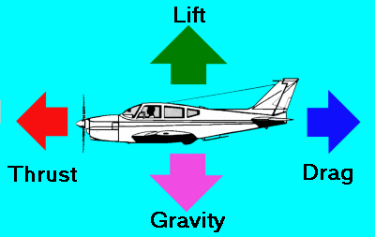

# **Introduction to Fusion 360**

**Fusion 360 is a CAE(computer aided engineering) designing tool from Autodesk.It is a cloud based 3D CAD tool which is very versatile and easy to learn and utilize.**

**Fusion 360 is an excellent tool for the precise modeling of 2D and 3D objects, but you can do much more with it, such as animate your designs, render objects, simulate loads,**

**Some of the great features and options of fusion 360 include,**

* **Parametric Modelling**
* **3D rendering**
* **Ease in exporting STL models for the 3D Printer.**
* **Programming of tool paths for CNC machines.**

**Apart from all these we can do analysis of our models like,**

* **finding the curvature of the surface**
* **Center of mass ,volume,surface area**
* **Various simulations**
* **Finite element analysis**

**Parametric Drawing:-It is basically designing with constraints of dimension and geometric relationship of objects with each other.This makes the features easy to edit later and lighter to store and process.**

**Generative Design:-It’s a great feature that suggests the design constraints and fusion 360 automatically suggests various possible solutions which help us in easily optimizing our model and come up with creative and cost effective designs.**

**Installing Fusion 360 for Personal Use**

1. **Visit Autodesk Fusion 360 website from the browser.**
2. **Find and click on the Personal use option in the opened window.**
3. **Click on Get started,Fill in all the cells with your personal details. Ensure you use your full name and a valid email address. Once finished click the create account button.**
4. **Complete the procedure by creating an account and verifying other checkboxes.**
5. **Once you’ve created an Autodesk account you will be able to download the Fusion 360 installer. Click on the provided download link for downloading Fusion 360.**
6. **Once the download is complete, you will need to locate and run the exe file to complete the download / installation process. Allow some time for the installation process to finalise.**
7. **Once installed, launch the Fusion360 desktop icon by double clicking it. A sign in window will appear and you will be able to log in, and launch the program.**

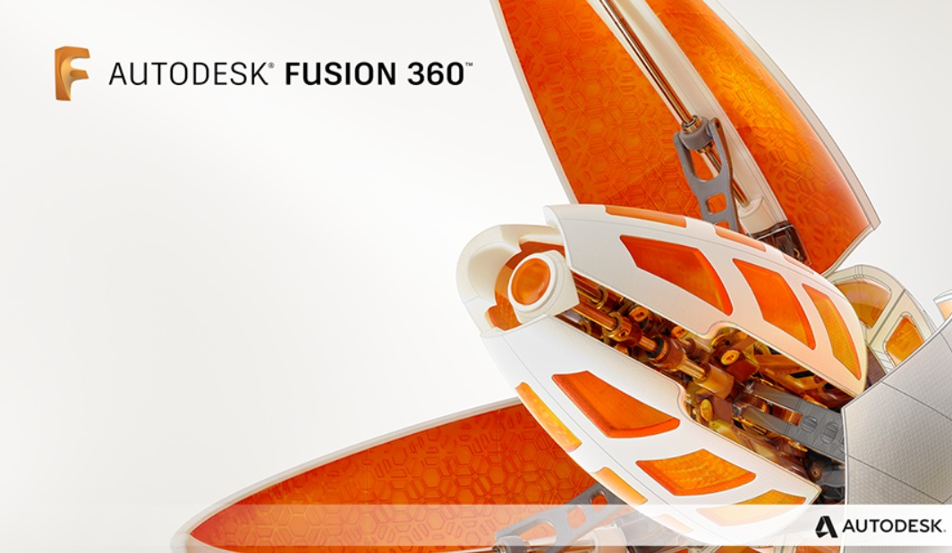

**If there occurs any issue while installation read the following article:-**

<https://knowledge.autodesk.com/support/fusion-360/troubleshooting/caas/sfdcarticles/sfdcarticles/Fusion-360-installation-troubleshooting.html>

## **Basic functionality of Fusion 360**

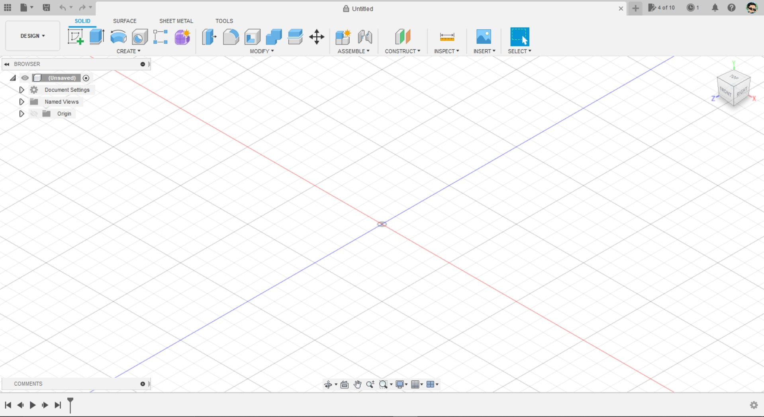

1. **Application bar:- The Application Bar is located in the upper lefthand corner.Within the application bar, there are 4 key areas:-Data panel, File menu, Save, Undo and Redo buttons.Across the top, you’ll see tabs that represent each design file.**
2. **Toolbar:- The toolbar allows you to select what type of workspace you would like to work in. It’s important to note that the tools on the toolbar will differ in each workspace.**
3. **View cube:- The view cube is the visual representation of the current view of the 3D environment.By this way we can get different views by just changing the orientation of the cube, a small home icon is at top of the cube to return to the default view.**
4. **Browser:-The browser lists objects in your design, including planes, sketches, parts, assemblies, and so on. You can think of the Browser as your file structure.Within the browser, you can change the visibility of objects as well as change your document units.**
5. **Canvas:- The middle section of Fusion 360 is where you’ll be sketching and doing all of your design work. Therefore, this section is referred to as the canvas.**
6. **Profile and Help:- Notifications,View job status, Fusion 360 update status, and online/offline status and your profile section appears here.**
7. **Navigation Bar and display settings:- The navigation bar contains commands used to zoom, pan(to move the image in the same orientation), and orbit(to view the screen from different sides) look at ,view ports (different views like orthographic, isometric) are present at the bottom of the screen.The display settings control the appearance of the interface. You can change the environment style (color), you can turn on and off ground shadows and other effects, turn grids on or off, or view your design from multiple views at once.**



1. **Timeline:- The timeline lists the order of operations performed on your design. Double-click on timeline features to quickly edit their properties. You can also right-click operations to make additional changes.Because Fusion 360 is a parametric modeling program, you can also drag the operations around to change the order they are calculated.**
2. **Various keyboard shortcuts are allowed in Fusion 360 which makes tasks easier.**

**[→ sometimes it is difficult to find and click on all the functions in such situations. With this keyboard short keys one can work more faster and efficiently.**

**Click on this:** [**Fusion 360 Keyboard Shortcuts, Hotkeys & Commands Guide**](https://www.autodesk.in/shortcuts/fusion-360) **]**

## **2D Sketching and 3D modelling**

### **Sketching:-**

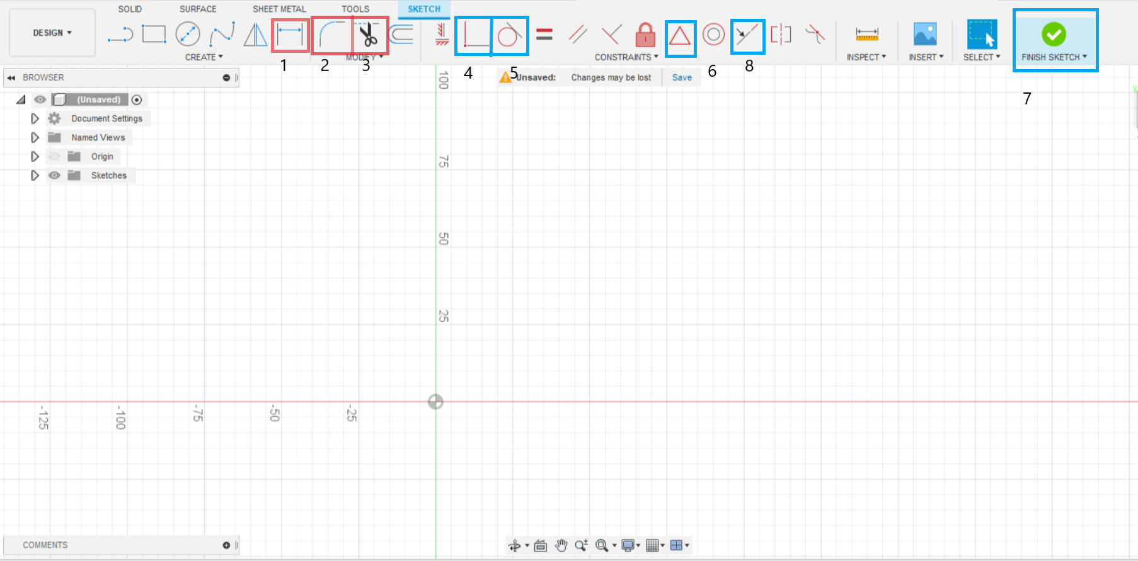

**For creating a 3D model first we have to create a sketch which is then extruded and edited to desired shape. But sketching is the most important step for a 3D model.**

**Click on the create option and then select the desired plane on which we are supposed to work. Then different sketching tools from line to rectangle .**

1. **Sketch dimension:- It is used to dimension the drawing,it is used to control size and position of the sketched objects, we can overwrite or edit the provided dimension by double clicking the previous dimensioned value.**
2. **Fillet:- It is used to place an arc of specified radius at the intersection of two lines or arcs.**
3. **Trim:- It is used to remove some portion of the curve till the nearest intersecting curves or boundary geometry.**
4. **Coincident:- Constraints two points or a line and a point or two curves together such that they become coincident.**
5. **Tangent:- It contriants the given line or curve to be tangent to the other surface.**
6. **Mid point: Contriants the point or object to the midpoint of the other object, or can be used to locate the midpoint by hovering over the desired line , the triangle symbol will appear at the mid point of the line.**
7. **Finish sketch:- After sketching is done, it is necessary to save the sketch by clicking on Finish, in order to move further.**
8. **Collinear:- It is a constraint used to make two lines collinear.**
9. **Similarly other constraints like parallel, equal, perpendicular are used to make two lines parallel, equal, and perpendicular respectively.**
10. **Lock:- This is used to fix the location of a point, line or a sketch such that it cannot be displaced.**
11. **Pattern tools:-Many pattern creating tools are also present to reduce the task to create the same thing. Just select the pattern tools like circular or rectangular pattern, then select the sketch of which pattern is desired, fill the number and direction and create the pattern.**

### 

### **3D modelling:-**

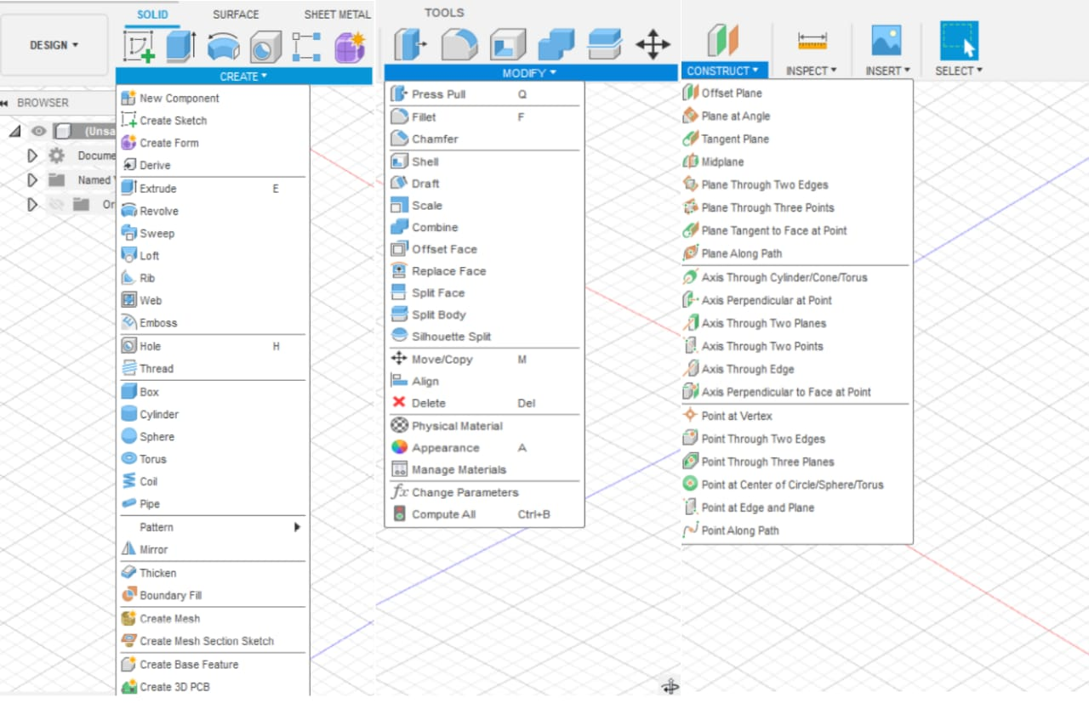

1. **Extrude:-** **It is used to extend the 2D sketch into a 3D model.we can either create a new body or Can just remove the material in the 3D model. One of the most important features in 3D modelling.**
2. **Hole:- It is used to create a cylindrical drill on the face we selected.As per the requirements we can select the thread type andthe diameter also for the hole.**
3. **Sweep:- It is the command used to create pipes or any other extensions that just create the sketch in any of the surfaces then make projections on the plane and select the path of the sweep.**

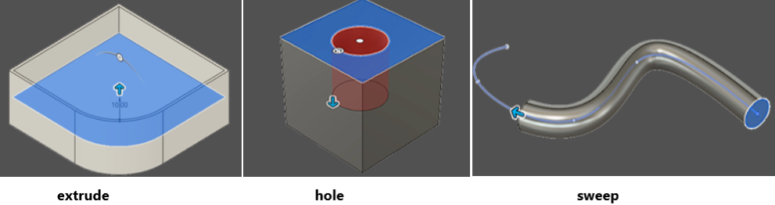

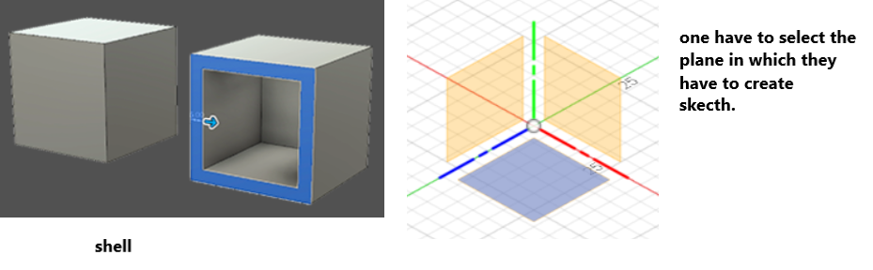

1. **Shell:- It helps to make a given solid into a shell by just entering the thickness of the shell. Just select the faces and surfaces and enter the thickness.**
2. **Fillet :- Sharp edges are needed to be removed sometimes to have a smooth curvature .It rounds the edges of the solid body by adding material to interior and removing the material from exterior.(similar thing is chamfer which can do a similar job but gives slant edges).Just select surfaces or faces you need to modify,it results as shown in below model.**

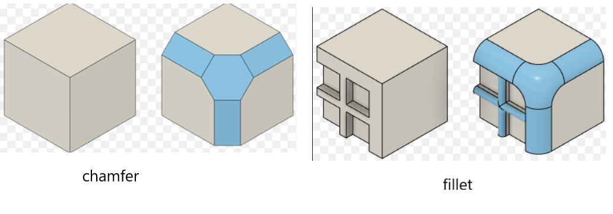

1. **Appearances:-Making pretty pictures or useful images might involve adding materials for a more realistic look or finish.These appearances are not the only ones you can use, you can also create your own materials either from scratch or by copying an existing material and making modifications to the copy.**
2. **Construct:- Under this section we can create different planes aligned at angle or at a distance from one another i.e. offset. Specify, the the fields in the dialogue box opened after selecting construct to the specified location where we want our plane.**
3. **Project:- Sometimes we may be stuck due to lack of reference (we may not be able to draw with fixed dimensions).In such a case, project command comes in handy.Firstly try to select the required plane which you need as reference,then one can access this command via sketch you can see from right side figure and after completion one can coloured lines like left fig.**

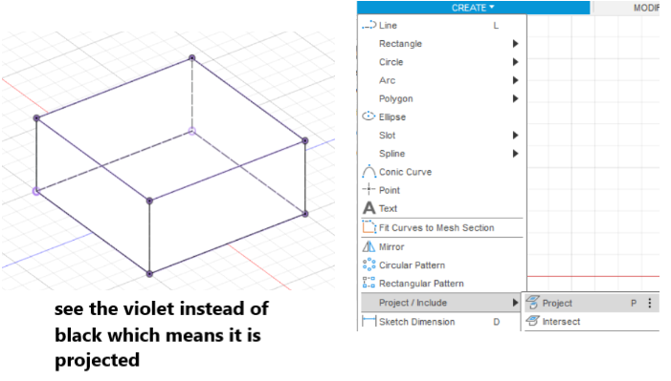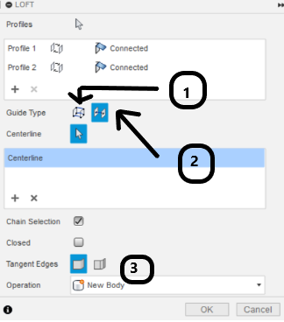

1. **Loft:- In this command we can join two surfaces either normally as shown in figure(a) for that we have to select a rail command in as shown in above pointer(1) or 3D extension with center line given (we have to make the center line for reference) as shown in figure(b) for this select (2)pointer and select the central line. We can also adjust the inclination of the extension as in figure(3).**

## **Assignment**

**Question:-**

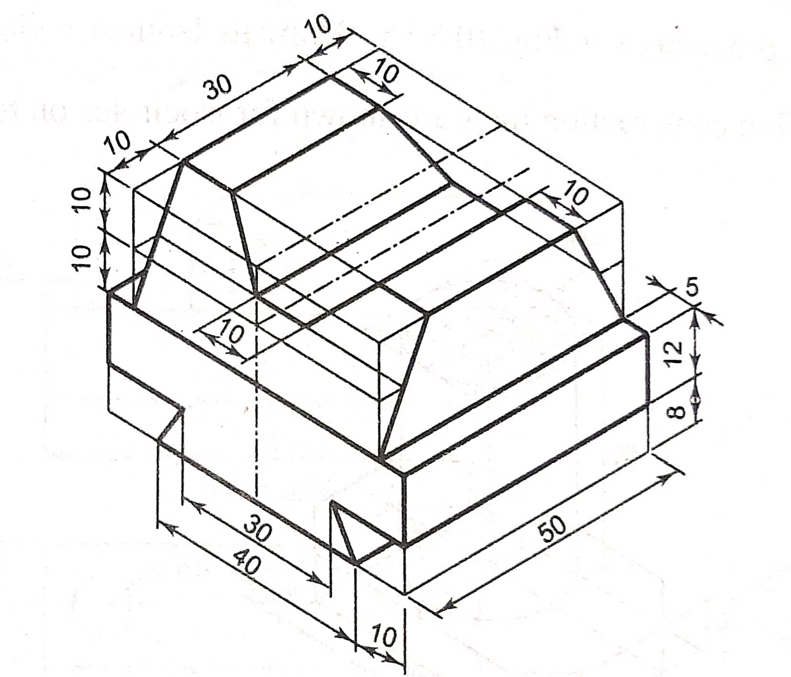

**Solution:-**

1. **Create a basic sketch using the available tools , dimension the lengths to constraint it, after sketching it ,click on finish .**

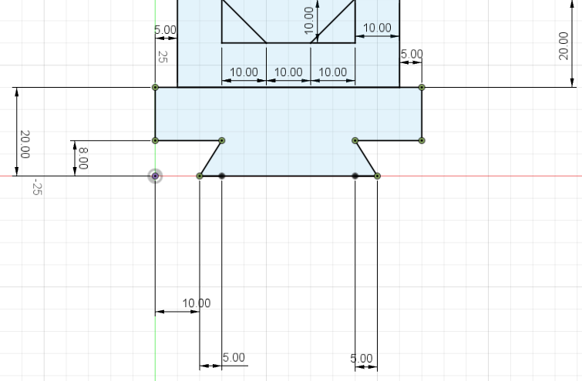

1. **After sketching extrude the sketch using extrude tool , fill the extrude dialogue box to provide the length in 3D**

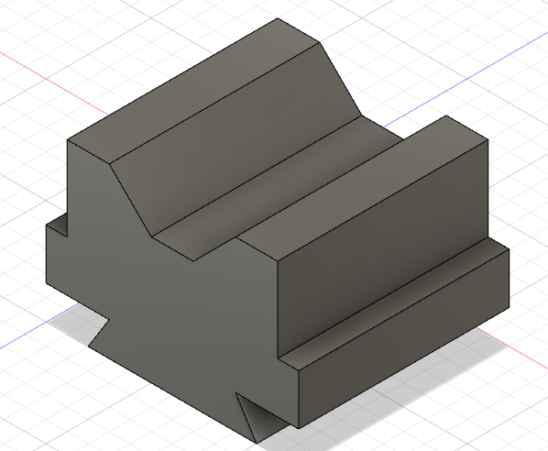

1. **After extrusion, sketch on one of the sides to get the desired shape ,either we can sketch simply or can construct a plane to create the sketch.**

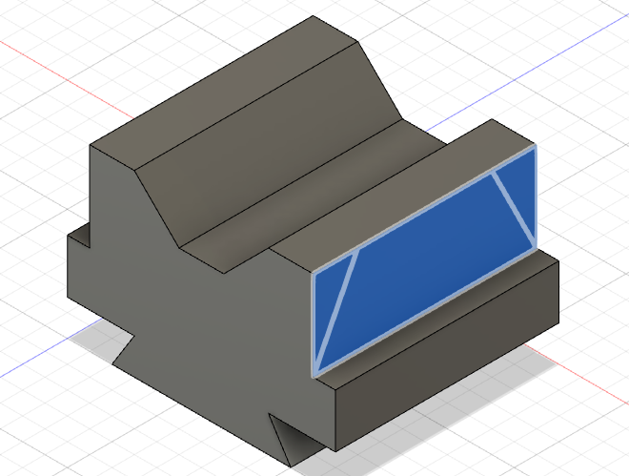

1. **Now extrude again the recent sketch but now we have to cut the volume instead of adding .After all we can add material, texture, colour using the appearance tool.**

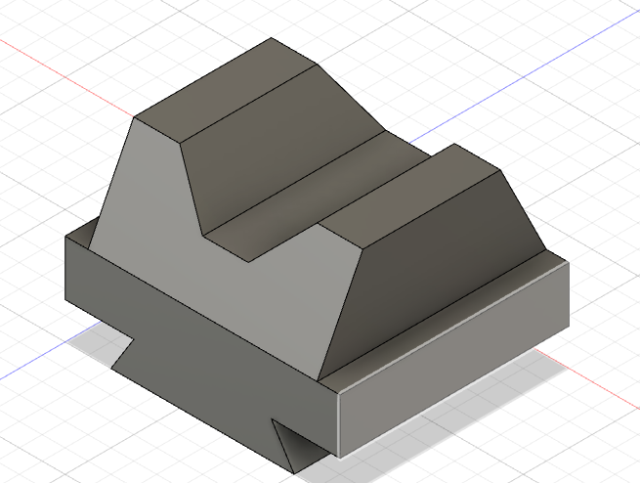

# **To be learned in the later part of the course:-**

* **Airfoil DAT to spline**
* **Designing airfoil in fusion 360**
* **Propeller modelling**
* **Basic plane modelling**
* **Form modelling**
* **Fuselage, Empennage and Rendering**
* CAD Designing Group 1
* **Aman Kumar Singh**
* **Ashish Sharma**
* **Beerakuppam Naveen Teja**
* **Padma Ram Rahar**
* **Shubham Kumar**
* **Vasu Paliwal**

# **THANK YOU**